Tech Spec: Balance Service
Author/s: Sajid Shaikh
Team/Pod: Payouts | BU: RazorpayX
Published Date: 5th March 2025

Reviewer Name | Reviewed Date | Status
Manas Saxena |  | Under review
Ayush Kumar |  | Not started

Table of Contents

1. Problem Statement 3
2. Introduction & Scope 3
2.1. Relevant Resources 3
3. Out of Scope 3
4. Futuristic Scope 4
5. Assumptions, Goals & Non-Goals 4
5.1. Assumptions 4
5.2. Goals 4
5.3. Non-Goals 4
6. Current Architecture / Current HLD 4
Lite Balance 4
CA Balance 4
Priority balance fetch 5
Non-Priority balance fetch 5
7. Final Approach - Specifications 5
7.1. Specifications 5
7.1.1. Balance update 5
Lite balance 5
Transaction creation - Success 6
Transaction creation - Low Balance 6
CA balance 7
High priority 7
Low priority 8
Rate limiting bank requests 9
For thread based limiting (RBL) 9
For TPS based limiting (Yesbank) 10
Error handling 10
Dual Write to API monolith 11
Balance Update Events 11
7.1.2. Balance fetch Dashboard API 12
Balance fetch - Cached (Default) 12
Balance fetch - Non cached 12
7.1.3. Balance creation 13
7.2. Assumptions 13
7.3. Possibility of Open Sourcing 13
7.4. Possibility on Patent 13
7.5. Data model/Schema Changes 13
7.5.1 Existing Schema 13
7.5.2 Proposed Schema 14
7.6. Business Logic Changes 17
7.6.1 APIs 17
7.7. Miscellaneous Questions 18
8. Non Functional Requirements (NFRs) 18
8.1. Scalability 18
8.2. Availability 19
8.3. Security 19
8.4. Compliance 19
8.5. Reliability 20
8.6. Infra Cost 20
9. Feature Dependencies & SLAs 21
9.1. Upstream Dependencies 21
9.2. Downstream Dependencies 21
10. Testing Plan 22
10.1. Test Cases 22
10.2. UAT Testing 22
10.3. Performance/Load testing 22
11. Go-live plan 22
11.1. Production Rollout and Ramp plan 22
11.2. Backward Compatibility 22
11.3. Rollback plan 22
12. Monitoring & Logging 22
13. Milestones & Timelines 22
14. Glossary 23
15. Appendix 23

1. Problem Statement
Context:
As part of API decomp we have identified balance service as a separate service that will be responsible for maintaining balance related information for Business banking accounts. This service will be responsible for balances related to merchant’s current as well as lite accounts.

Problem Statement:
The aim of this document is to extract the balance module from the API monolith to a separate service with a purpose of redesigning the following:
- Balance fetch for current accounts from the bank
- Fetching of account balance for internal service like payouts.

2. Introduction & Scope
This document covers the details of functionalities moved:
- Current account
  - Balance Fetch from respective banks
  - Balance fetch prioritization for different merchants
- Lite accounts
  - Transaction creation on CLS (ledger service)
  - Balance fetch for lite accounts from CLS
- APIs around Balance fetch for both the Current and Lite accounts
- Balance entity creation during merchant onboarding

2.1. Relevant Resources
Existing solution on API monolith:

- Balance Fetch Optimisation Tech Spec
- [Tech Draft] Prioritized Balance Update

3. Out of Scope
This document will only determine the storage and updation of balance and not the details regarding the integration and usage of this balance.

4. Futuristic Scope
- Storing Master<>Sub account balance mapping information.
- Probable service for storing virtual account information since it is closely related to account balances
- Fetching Primary balance from PG balance service for specific use cases
- Port out bank TPS/thread based rate limiting into a separate dynamic rate limiting service

5. Assumptions, Goals & Non-Goals

5.1. Assumptions
None.

5.2. Goals
- Balance fetch from bank functionality to be moved out of API monolith
- APIs around Balance to be moved out of API monolith
- SLAs to remain the same as that of the API monolith solution. i,e, refresh CA merchant balance every 5 mins for priority merchants and maximum within an hour for non priority.
- Lite account balance will be powered by CLS, while balance service will be the central service for any balance related information required by internal services

5.3. Non-Goals
Not applicable.

6. Current Architecture / Current HLD

Lite Balance
For lite account merchants, we are currently fetching balance from CLS. CLS maintains the ledger for all the lite merchants. Any credit/debit action performed via payouts and fund loading events are captured in CLS by making an API call to CLS directly by internal services like payouts. CLS remains the only source of truth for deducing balance for a given lite merchant.

CA Balance
Banks are the source of truth for CA merchant’s balance. We rely on fetching this information directly from the bank instead of storing it in our database or CLS. The reason for this is because merchants can do an external transaction using their current account and we would not know the balance post those transactions.
Currently, we have two CRONs configured for balance fetch:
- Priority balance fetch
- Non-Priority balance fetch

Priority balance fetch
We have a priority queue configured for each channel (RBL and ICICI currently). CRON runs every 5 mins and dispatches balance fetch jobs for high transacting merchants. These jobs are prioritized by the balance fetch workers over Non-priority balance fetch jobs. The reason for introducing this was to ensure that for high transacting merchants, balance fetch is guaranteed to be every 5 mins.

Non-Priority balance fetch
This is the default balance fetch that runs for every merchant except the prioritized ones. We have a default balance fetch queue per channel i.e, RBL, ICICI, Connected banking (axis, yesbank) CRON runs every minute and dispatches a maximum of 600 MIDs for balance fetch. Following is the strategy to choose these MIDs:
- Balance should be fetched every minute for any merchant who has done a payout in the last 30mins.
- Balance should be fetched every minute for any merchant whose balance changed in the last 30 mins.
- Balance of every merchant should be fetched at least once every 10 mins irrespective of whether the merchant has done any transaction or not.

7. Final Approach - Specifications

7.1. Specifications

7.1.1. Balance update

Lite balance
In the new balance service, we will continue with migration of the existing solution where we rely on CLS to be the source of truth.
The only change that will be done is that the Internal services, like payouts, will call the balance service instead of directly calling CLS and balance service will handle all the related operations by calling CLS in return. This way, balance service remains the source of truth for all the internal services for any of their balance related operations.

Transaction creation - Success
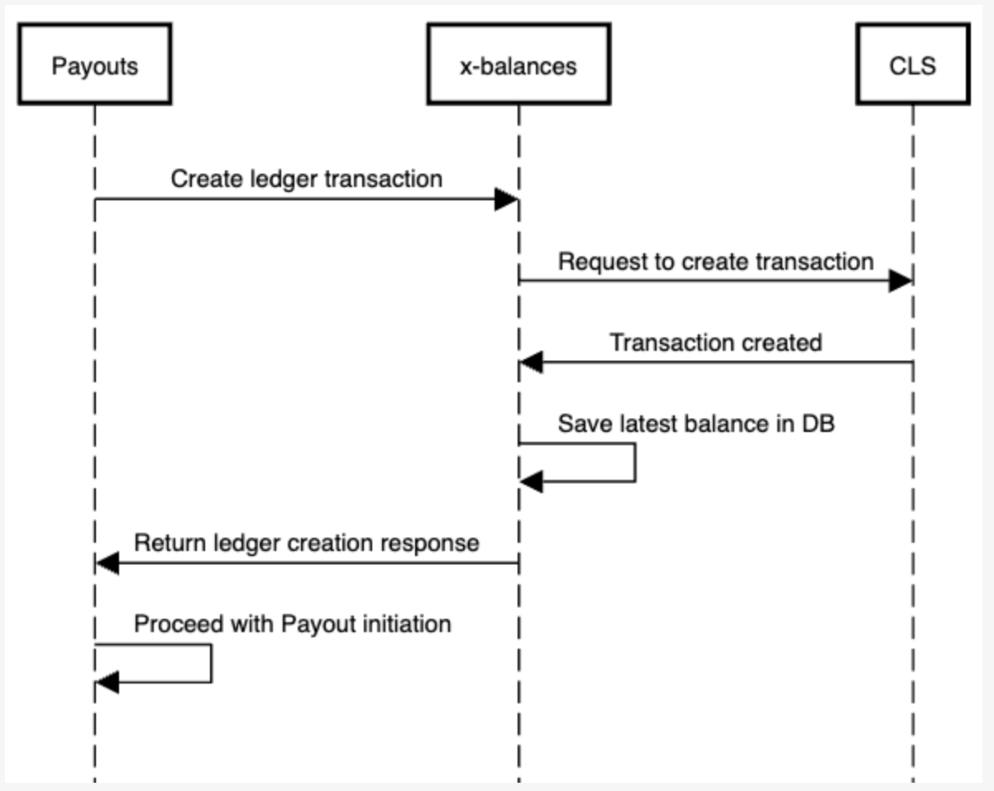
Transaction creation on CLS by services like Payouts will be done through balance service. Balance service will send a request to CLS for transaction creation and post successful response, the latest balance in the response payload will be stored in balance DB.

Transaction creation - Low Balance
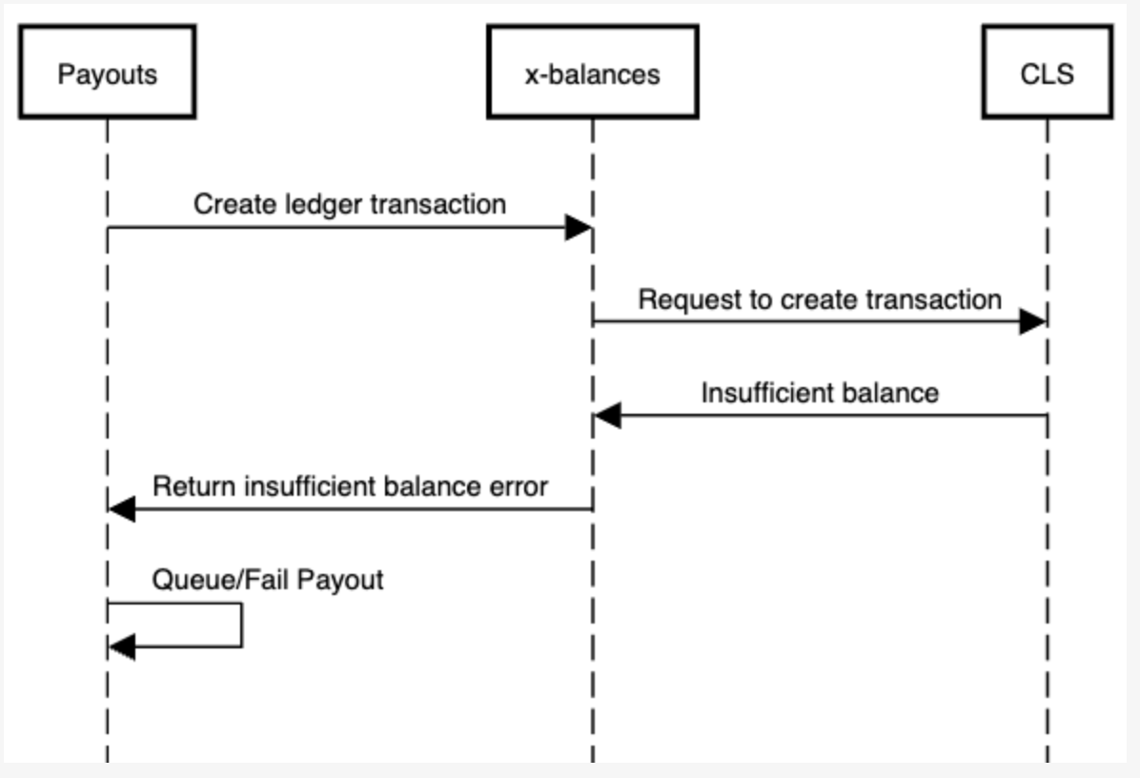
In case of insufficient balance response from CLS, balance service will return an error to the downstream service like payouts, which will in turn proceed with queueing or failing the payout.

CA balance
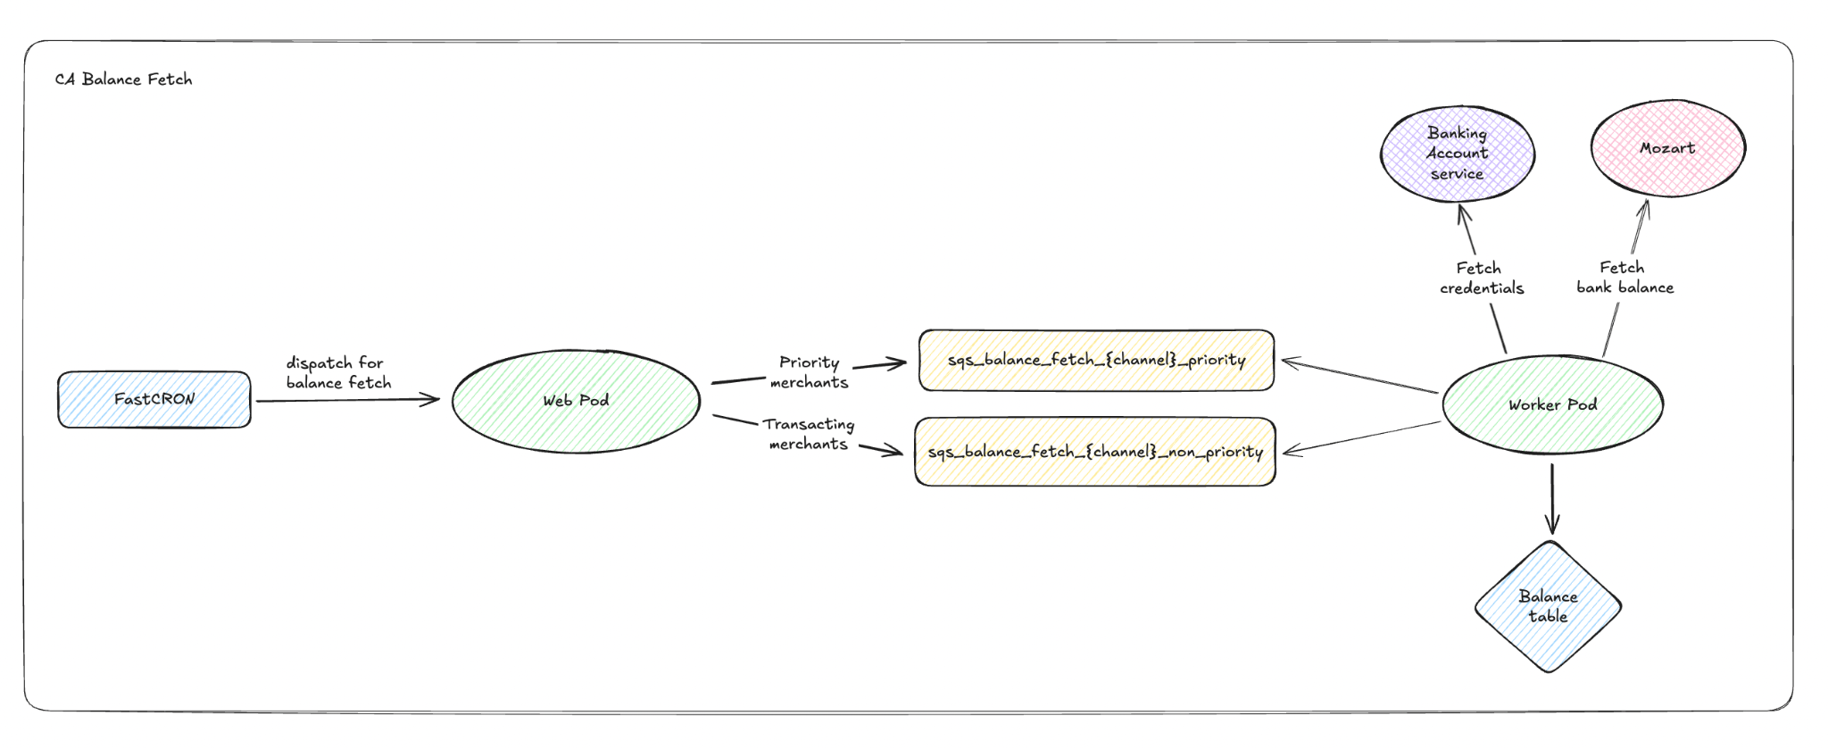
As part of the balance update decomp, we will have a similar approach where for each channel we have two queues i.e, high-priority, low-priority.
Two CRONs will be set up.
- Every 5 mins for high priority
- Every 1 mins for low priority
We will be setting up two CRONs, one to dispatch high priority merchants and the other to dispatch low priority

High priority
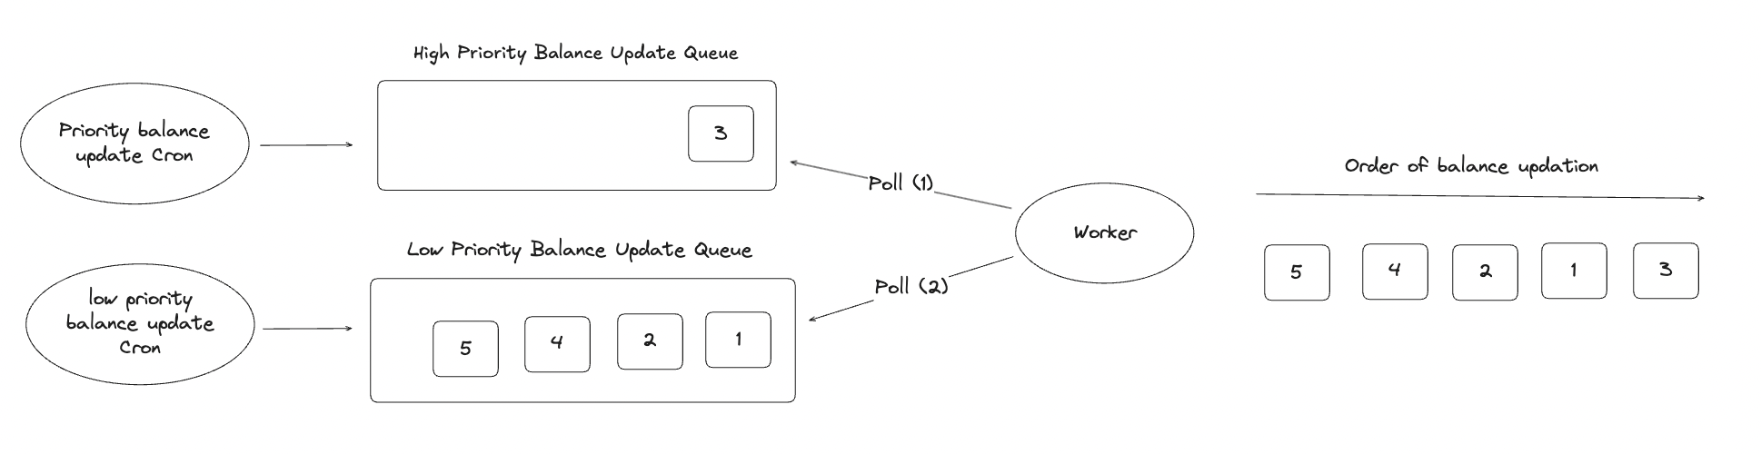
- We will be able to set the priority of the merchant based on a column in the db called priority. For high priority, value will be 2. Higher the number, higher the priority
- We will fetch all high priority merchants and dispatch them for update. While fetching high priority merchants from the db, we will use priority = 2 filter.
- Balance fetch worker will have a condition to fetch balance only if last_fetched_at was more than 3 mins ago. This is to ensure that we don’t repeatedly fetch balance for the same merchant in case of a queue pile up and instead use the bank TPS efficiently.
- Note: High priority merchant balance fetch guarantees a balance fetch every 5 mins and there is currently an upper limit on the number of merchants that can be set to high priority i,e. 1200 merchants. This is due to the TPS restrictions that we currently have for different banks.

Low priority
- Compared to the current solution, we will have a change in the logic for dispatching low priority merchants for balance update.
- The limit for dispatching merchants every minute will be stored in redis as well and the default limit will be 600. This is the same as the current approach.
- We will be having two buckets for dispatching merchants for balance fetch,
- Bucket 1: Based on the payout volume
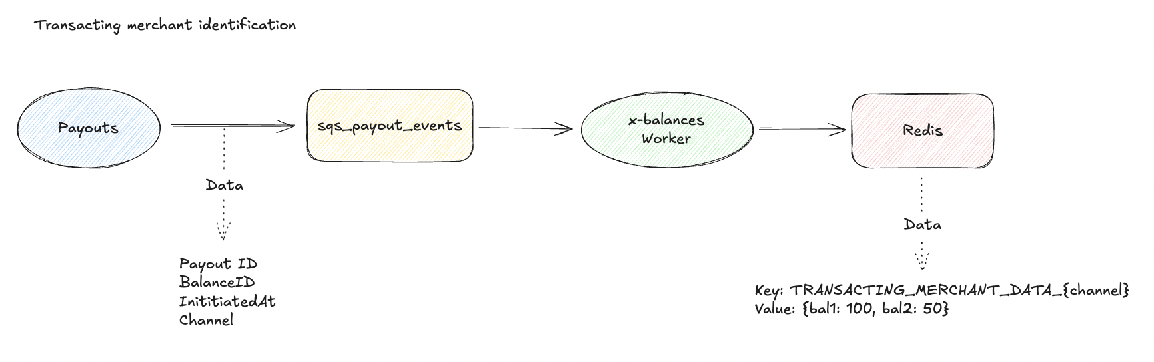We will be receiving payout creation events for the merchants via an event queue. Based on this, we will set a counter in redis for each balance_id. As soon as there is a payout created, this payout data will be pushed to the queue. A worker in balance service will poll this queue and accordingly increment the counter for the balance_id specified in the event. This redis key will be of the format,
Key: TRANSACTING_MERCHANT_DATA_{channel}
Value: {balanceID1: 100, balanceID2: 50}

For every balance update CRON hit, top 400 merchants will be dispatched for balance fetch based on the descending order of their count.
Post balance fetch for these merchants, count will be reset to 0 so that other transacting merchants can be prioritized.
- Bucket 2: Merchants whose balance was least recently updated (Round robin)
After picking merchants from Bucket 1, we will query the db to find the merchants whose balance was least recently updated (based on last_fetched_at timestamp)
200 such merchants will be picked up and pushed for balance update.
We need this to ensure that all merchants have their balance updated at least once per day in case they are not transacting or low transacting.
- The priority for all merchants by default will be set to 1. While fetching merchants for low priority balance updates, we will use priority = 1 as a filter to avoid including high priority merchants.
- Balance fetch worker will have a condition to fetch balance only if last_fetched_at was more than 3 mins ago. This is to ensure that we don’t repeatedly fetch balance for the same merchant in case of a queue pile up and instead use the bank TPS efficiently.

Rate limiting bank requests
Every bank has different rate limits defined. This can be based on the number of threads that are available (e.g. RBL) or based on TPS (e.g. Yesbank)

This can be solved by using channel based rate limiters. We will be using redis based rate limiters.
The data in redis for rate limiter tokens will be of the format,
Key: BALANCE_FETCH_THROTTLING_LIMIT_{channel}
Value: 15

The data in redis for rate limiter type for a channel will be of the format,
Key: BALANCE_FETCH_THROTTLING_TYPE_{channel}
Value: TOKEN_BUCKET or SLIDING_WINDOW (either one)
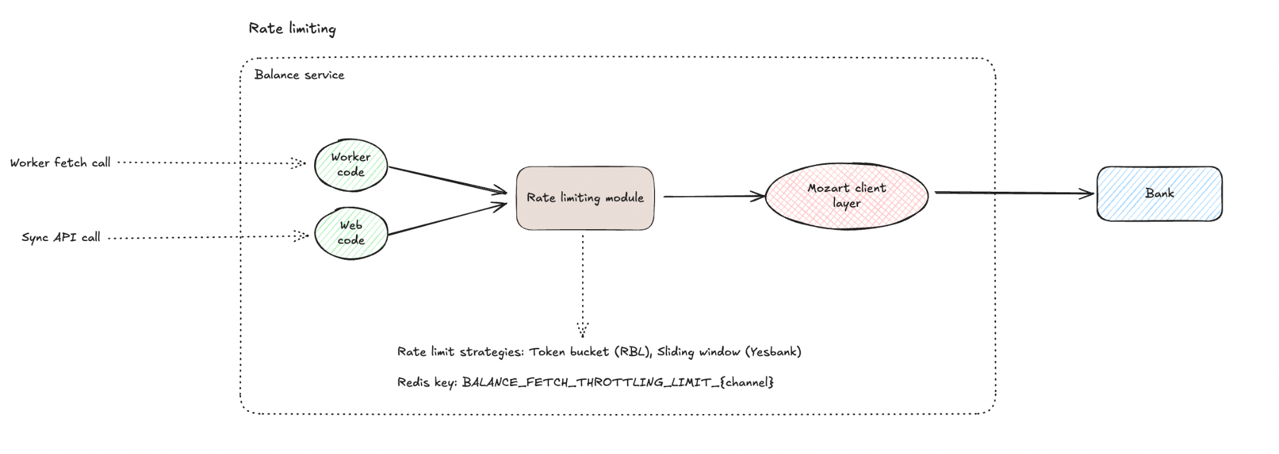

For thread based limiting (RBL)
- We will implement rate limiting using a token bucket strategy.
- Every balance fetch call to RBL will have a rate limiter at the client layer.
- A total of 15 tokens will be available and processes will have to acquire a token before fetching.
- Beyond 15, requests will be throttled at the client layer (Mozart layer)
- Out of these 15 tokens, 3 tokens will be reserved for sync API calls via merchant dashboard or private auth and remaining 12 tokens will be reserved for async calls done via balance fetch workers.

Handling throttling for async calls
- If a worker's request is throttled, it will be pushed back in the queue.

Handling throttling for sync calls
- If a merchants request is throttled, we will return the balance from the DB
- In the response of this api, we also have last_refreshed value. This will be the latest if the request was not throttled since we will fetch balance from the bank. If throttled, it will be the last fetched at value saved in the db.

For TPS based limiting (Yesbank)
- For Yesbank, we will implement rate limiting using a sliding window strategy
- Every balance fetch call to RBL will have a rate limiter at the client layer.
- Total of 2 requests will be available for processes every second
- Beyond 2, requests will be throttled at the client layer (mozart)

Handling throttling for async calls
If a worker’s request is throttled, it will be pushed back in the queue.

Handling throttling for sync calls
- If a merchants request is throttled, we will return the balance from the DB
- In the response of this api, we also have last_refreshed value. This will be the latest if the request was not throttled since we will fetch balance from the bank. If throttled, it will be the last fetched at value saved in the db.

Future Scope: When we develop a global rate limiter service, we can then port these configs to that service and rate limiting will shift from client layer to a separate service and rest of the functionalities will work the same way.

Error handling
- In case a balance fetch job fails for retryable error, we will push the job back to the queue with a 5 second delay.
- We will perform two retries for the job before deleting it from the queue. Only retriable 5XX errors will be eligible for this.
- For non 5XX errors, we will raise an alert immediately as this is not an expected behavior and can cause the balance fetch to repeatedly fail for a merchant.
- We will add appropriate logs and push metrics for monitoring purposes in case a job exhausts its retries.
- In case of a rare event where redis goes down and we are not able to identify the transacting merchants for low priority balance fetch, the entire limit of 600 merchants will fall back to Bucket 2 and work in a round robin manner to ensure balance fetch does not fail.

Dual Write to API monolith
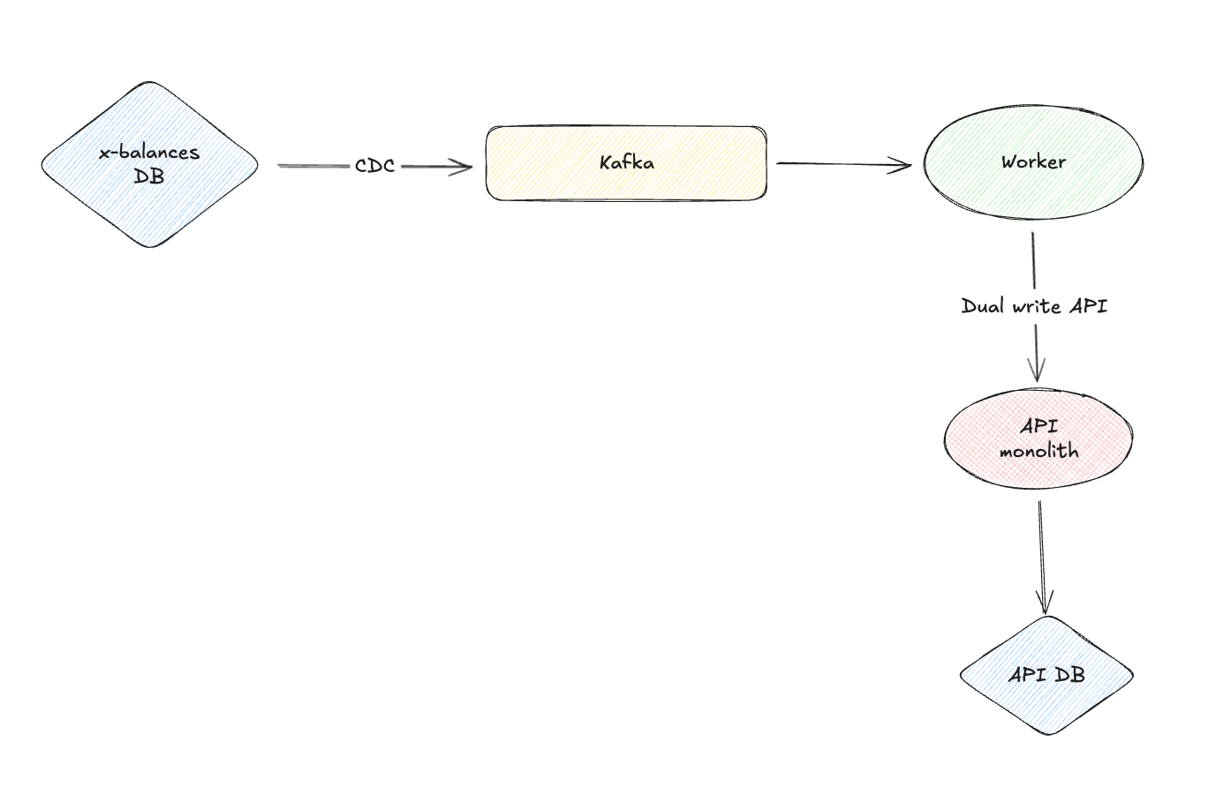
Balance service development is broken down into multiple milestones, where the first milestone comprises only CA balance fetch from the bank. Since read APIs will still be powered by API monolith here, we will need to update the tables in API DB.
Any insert/update operations on the balance service’s balance table will be captured as a CDC event and pushed to kafka. This event is then consumed by the worker and an API call is made to API monolith over a route that will update the balance in banking_account_statement_details, balance, settings table where balance is being referred to from different flows in API monolith.

Balance Update Events
When the balance is updated for CA/Lite accounts, we will push an event to the data lake with information such as balance, previous_balance, balance_id, balance_updated_at, merchant_id.
Since the balance table will always store point in time data, events table on lake will help in recording every balance change event for analytics purposes such as:
- Get the end of day balance (Last balance event for the day)
- Balance change delay trend analysis.

7.1.2. Balance fetch Dashboard API
Balance service will expose an endpoint to fetch balance for Lite/CA merchants. This will cater to all external (Admin dashboard, Merchant dashboard, Private auth) or internal use cases (Payout service).

Balance fetch - Cached (Default)
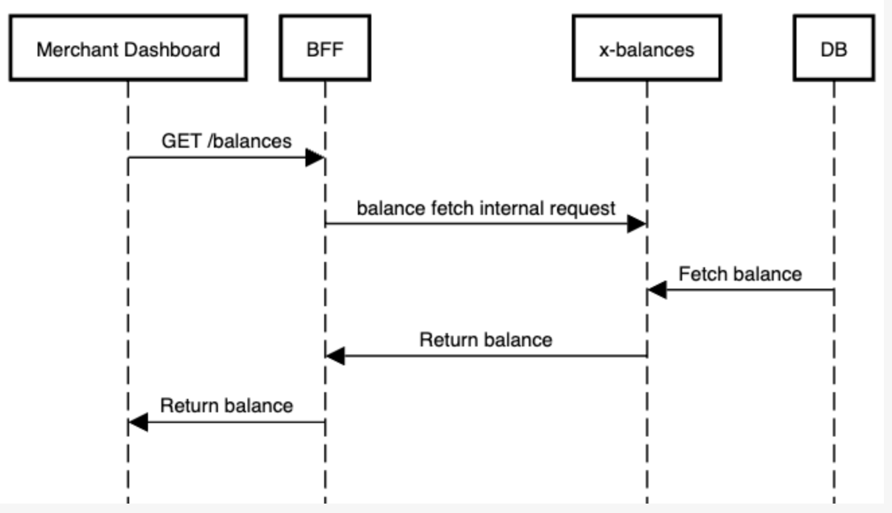
For API calls to fetch all balances for the merchant or for a specific balance id, we will return the response that is stored in our DB. This will be the default behavior where we do not fetch the latest balance from CLS and instead return the stored balance.
Note: This will be the same API which caters to the balance fetch API requests via Private auth where we do not fetch the latest balance, rather return the balance from the DB

Balance fetch - Non cached
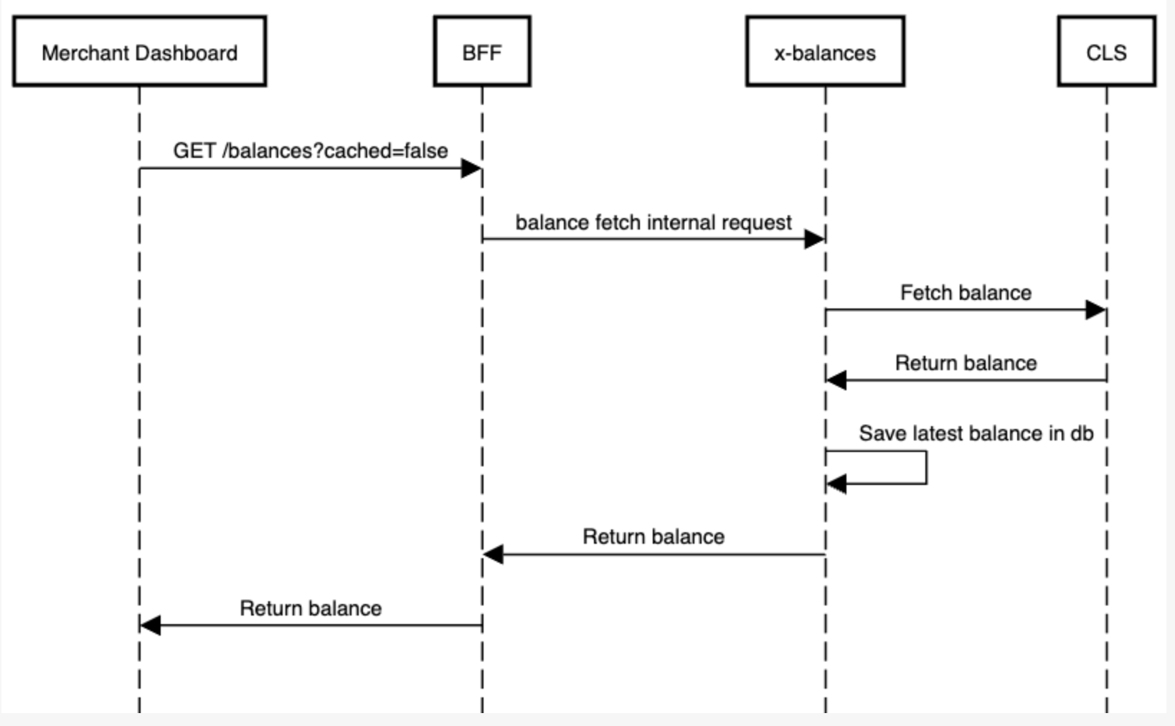
For API calls to fetch all balances for the merchant or for a specific balance id, when the cached parameter is sent as false, we will fetch the latest balance(s) from CLS. This will then be saved in our DB and response will be returned.

7.1.3. Balance creation
<TBD>

7.2. Assumptions
None.

7.3. Possibility of Open Sourcing
Not applicable.

7.4. Possibility on Patent
Not applicable.

7.5. Data model/Schema Changes

7.5.1 Existing Schema
Table: banking_account_statement_details
Columns:
- id: Primary Key
- merchant_id: Identifies the Merchant
- account_number: Account number of the Current / Pool account
- balance_id: Refers to balance table in API monolith. Identifies "banking" balance for this Account
- channel: Identifies the Bank, ex values: rbl, icici
- status: Account status, used to figure out if statement fetch is to be done or not. One of values: active, inactive, under_maintenance, archived. Statement fetch is done only for "active" accounts
- statement_closing_balance: Closing Balance as per the last account statement transaction fetched thus far
- gateway_balance: Account Balance fetched using Bank APIs
- statement_closing_balance_change_at: Timestamp at which statement_closing_balance was last updated
- gateway_balance_change_at: Timestamp at which gateway_balance was last updated
- created_at and updated_at: Row created and updated timestamps in unix timestamp
- last_statement_attempt_at: Timestamp when latest attempt to fetch Account Statements was made
- balance_last_fetched_at: Timestamp at which Account Balance was last fetched
- pagination_key: Pagination key shared by Banks to identify the cursor till which the Account Statements are fetched thus far. Format: <last_transaction_posted_date>_<actual_pagination_key_from_banks>. Last transaction posted_date is prefixed to the pagination key to identify the freshness of Pagination Key
- account_type: Used to identify if it's a Current Account or Pool Account. Value will be "direct" for Current Accounts and "shared" for Pool Accounts
- last_reconciled_at: Timestamp at which last reconciliation for the missing statement transactions was made
Table: balance
Columns:
- id: Primary Key
- merchant_id: Identifies the Merchant
- account_number: Account number of the Current / Pool account
- account_type: Identifies the type of the account, values: shared/direct
- balance: Stores the balance amount for the account
- channel: Identifies the Bank, ex values: rbl, icici
- credits: Stores the credits available for the merchant account
- currency: Identifies the currency configured for the merchant account, ex value: INR
- fee_credits: Stores the fee credits available for the merchant account
- locked_balance: Stores the balance to be referred while creating transactions
- name: Identifier for the merchant account
- on_hold: Identifies the funds that are on hold
- refund_credits: Stores the refund credits available for the merchant account
- type: Identifies the type of the merchant account, primary/banking
- created_at: Row created at timestamp in unix timestamp
- updated_at: Row updated at timestamp in unix timestamp

7.5.2 Proposed Schema
Ref: https://dbdiagram.razorpay.com/dbdiagram/fetch/8fcb5288-ef84-11ef-89fc-0e2594aaf866

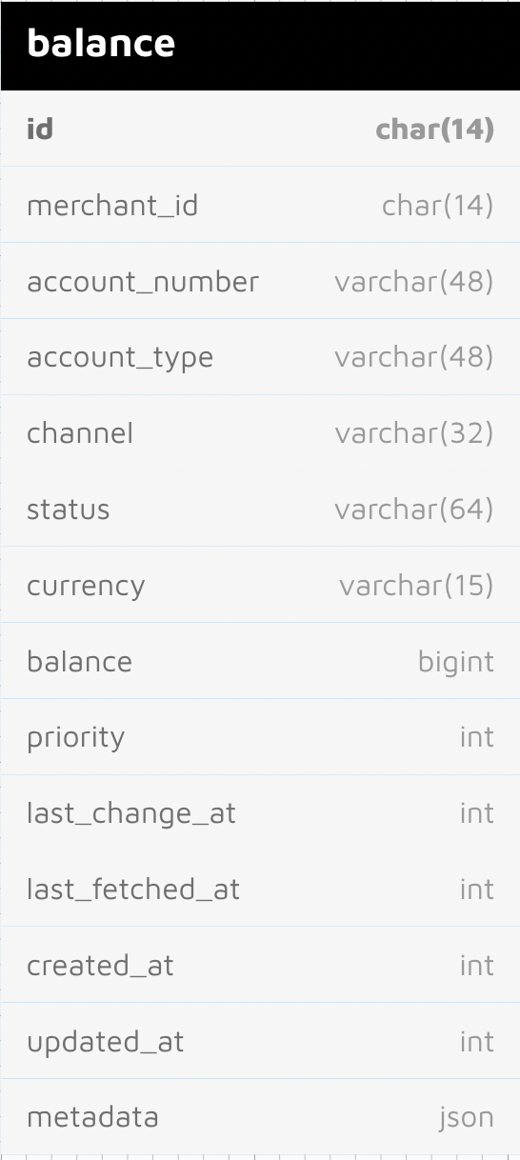

CREATE TABLE `balance`
(
`id` char(14) CHARACTER SET utf8mb4 COLLATE utf8mb4_bin NOT NULL,
`merchant_id` char(14) CHARACTER SET utf8mb4 COLLATE utf8mb4_bin NOT NULL,
`account_number` varchar(48) CHARACTER SET utf8mb4 COLLATE utf8mb4_bin NOT NULL,
`account_type` varchar(48) CHARACTER SET utf8mb4 COLLATE utf8mb4_bin NOT NULL DEFAULT 'direct',
`channel` varchar(32) CHARACTER SET utf8mb4 COLLATE utf8mb4_bin NOT NULL,
`status` varchar(64) CHARACTER SET utf8mb4 COLLATE utf8mb4_bin DEFAULT 'active',
`currency` varchar(15) CHARACTER SET utf8mb4 COLLATE utf8mb4_bin DEFAULT 'INR'
`balance` bigint DEFAULT NULL,
`metadata` json DEFAULT NULL,
`priority` int DEFAULT 1,
`last_change_at` int DEFAULT NULL,
`last_fetched_at` int DEFAULT NULL,
`created_at` int NOT NULL,
`updated_at` int NOT NULL,
PRIMARY KEY (`id`),
KEY `balance_account_number_status_index` (`account_number`, `status`),
KEY `balance_priority_index` (`priority`),
KEY `balance_last_fetched_at_index` (`last_fetched`),
KEY `balance_merchant_id_channel_index` (`merchant_id`, `channel`),
KEY `balance_balance_id_index` (`balance_id`),
KEY `balance_channel_index` (`channel`)
)
ENGINE=InnoDB DEFAULT CHARSET=utf8mb4 COLLATE=utf8mb4_0900_ai_ci

As part of decomp, we will be creating a new balance table to the balance info. This is done in order to normalize the db table to extract balance related information from the banking_account_statement_details table. This will be similar to the current balance table in API db, with a few new columns,
- metadata: This column will be utilized to store meta information such as OD balance configured for the merchant.
- status: We will be adding this column with default value as `active`. It makes sense to add this column since at times during a suspected fraud case, we have to take measures to block the merchant’s account (lite or CA) to restrict payouts. A status like `blocked` on the balance entity can be leveraged as a single place for such payout related operations.
- priority: This table is used to store the priority of balance fetch for CA merchants

There are few other columns that we will not be including in the new balance table,
- fee_credits: We do not store fee credits against a balance, its a pricing information available in another table called credits
- locked_balance: This was introduced before CLS for lite accounts. Currently, we use the balance from CLS directly
- name: The only usage for this column currently is to fill the values enabled/disabled during ledger cutoff. We do not fill an identifier for the merchant account during creation
- on_hold: We do not use this column for in banking balance, only the balance is used
- refund_credits: We do not use this column for banking balance, its a pricing information

7.6. Business Logic Changes

7.6.1 APIs
API | Initiate Balance Fetch  API triggered by FastCron to initiate Balance fetch for Current Accounts using Bank APIs
Request  POST | https://x-balances-ext.razorpay.com/v1/cron/balance/{channel}/fetch  {  "merchant_ids":[],  "blacklisted_merchant_ids":[],  }  merchant_ids: List of merchants for whom balance fetch will be dispatched. When passed, balance fetch dispatch will only consider these merchants for balance fetch initiate  blacklisted_merchant_ids: List of merchants for whom balance fetch dispatch will be excluded
Headers | Authorization: Basic <FastCron Credentials>  Content-Type: application/json  Accept: application/json
Response | {  "dispatched_accounts": [  "<balance_id_1>",  "<balance_id_2>",  "<balance_id_3>",  "<balance_id_N>"  ]  }

- Pseudocode
- Flowcharts
- Error states
- Failure scenarios
- Conditions that lead to errors and failures
- Limitations

7.7. Miscellaneous Questions

8. Non Functional Requirements (NFRs)

8.1. Scalability
Writes in Balance service will happen when,
- Lite account: When we fetch balance from ledger or when we send a request for transaction creation
- Current account: When we fetch balance from the bank periodically via a CRON hit

Read traffic for balance service will come in from,
- Read API exposed on the UI to fetch balance
- Read API exposed over private auth to the merchants for fetching all their balances

Balance service workloads will be deployed on Kubernetes(k8s). These deployments can be horizontally scaled to a great extent. Heavy workload in balance service is with fetching balance using Bank APIs, this will be managed using background jobs deployed as separate k8s deployments - this can be scaled horizontally as well.

However, with web deployments - that serves HTTP traffic - we will have rate limiting on the balance fetched by merchants
Internal calls for transaction creation will be relayed to ledger, hence db load will not be greatly affected

Following are the different database operations in context,

CREATE: Creation will only be triggered by new onboarding and will not add much load on data base and web deployments

UPDATE: Update calls will be done majorly when there is a balance change for a CA or lite merchant. This will add to the workload when we onboard more merchants. Horizontal scaling can help with scaling requirements on deployments. As for db load, our worker pods will be rate limited to ensure that we do not use more threads/tps alloted by the bank APIs. This indirectly keeps the Write IOPS in check and shields our db from high loads.

READ: Our fetch balance and fetch balance by id APIs wil be responsible for the read operations.
These calls will have rate limiting enabled on edge layer as well as on the application layer to control the Bank API calls we make. Thus, controlling the db load. Incase we need to scale the read operations in future, we can add read replicas to handle this.

8.2. Availability
Balance service will play a crucial role in payout processing flows, hence our read APIs need to be highly available and balance for the merchants

Lite account ledger transaction creation: Aim will be to have an uptime greater than or equal to that of CLS to ensure that balance service does not become a bottleneck for payout creation.

CA Balance Fetch: We will have the following SLAs in place,
Priority merchants: Once every 5 minutes
Transacting merchants: At least once every 15 minutes
Non transacting merchants: At least Once per day

Balance Reads: we will aim for an uptime of 99.97% (this is the baseline - as per API monolith routes)

8.3. Security
Balance service will be accessed by both internal and external clients.

Internal clients:
Payouts: for ledger transaction creation, balance fetch

External clients:
Merchants: via X Dashboard to access account balance
Admin users: via Admin Dashboard, for entity fetch and balance creation, trigger balance fetch
FastCron: to trigger CA balance fetch

Internal clients and FastCron will be authenticated using Basic Auth and there will be checks to ensure which API endpoints can be accessed by which user. On the APIs accessed by FastCron, there will also be IP whitelisting done on FastCron IPs

Calls from Merchants and Admin users will be authenticated at the Edge/Kong layer and the Passport JWT set at that layer will be validated at the Balance service. Additionally, for merchant accessed APIs, there will be checks to ensure the merchant is accessing their own data.

8.4. Compliance
Not Applicable.

8.5. Reliability
The main goal of balance service will be to maintain and return the available balance for the merchants for display as well as in critical flows like payout creation. Hence the correct data being present and regularly updated is of utmost priority.

Lite account: CLS is the source of truth for lite accounts while balance service is responsible for proxying the request. We will be ensuring that all the error handling and edge case handling is in place before we go live with test merchants.

Current account: Banks are the source of truth for this data. Inaccuracies either result due to incorrect responses from the Banks or due to incorrect processing of the data at our end. On the later part, in the initial few days of the migration of balance fetch from API monolith to the new service, we will be running the infra in a shadow mode and comparing the data received at both the places.

8.6. Infra Cost
Balance service will be deployed on Kubernetes. There will be k8s Deployments to handle Web/HTTP traffic, to handle balance Fetch and to handle balance reads. These deployments will be horizontally scaled using k8s HorizontalPodAutoscalers. Related to this infra, we will have visibility into the infra cost post Performance testing.

DB operations
Write TPS (for RBL):
Max 15 threads, consider 30 for future use case
Assume that for the bank's response, the best time is 1 second.
So write will be at 30 TPS

With multiple banks fetching data simultaneously, average TPS would come up to around 80 TPS

Read TPS (for RBL):
Reads are rate limited as per bank TPS. Hence the worst case for read will be the max TPS for a bank i,e. 30 TPS in case of RBL.
Thus, with multiple banks, we also keep the overall average TPS for read as 80 TPS

For storage, we will need a Database instance - AWS Aurora cluster with one reader and one writer of type db.r6g.large with two nodes - this is costing ~520$ / month

SQS Cost
Consider for RBL
Priority merchants = 1000 per 5 mins = 288000 per day
Non priority merchants = 600 per min = 864000 per day
Total = 1152000 messages per day.

To consider merchants on other banks and new onboarding on RBL, we double the count of messages
So, 1152000 * 2 = ~2300000 messages per day
So ~70000000 messages per month

70M messages per month and every message will have send, receive and delete requests.
So a total of approximately 210 million requests per month
Total cost for this will be $84 per month

Infra cost summary: X-Balances Infra cost

9. Feature Dependencies & SLAs

9.1. Upstream Dependencies
Sr. No. | Service | Impact | SLA (if applicable) | POC for service
1 | Mozart | Balance service won't be able to access Bank APIs to fetch Account Balance
2 | Banking Accounts Service | Balance service won't be able to fetch credentials needed to make Bank API calls
3 | CLS (via AWS SNS) | Balance service won't be able to create transactions and fetch balance for Lite accounts

9.2. Downstream Dependencies
Sr. No. | Service | Impact | SLA (if applicable) | POC for service
1 | Payouts | Payouts won’t be able to create transactions on ledger, fetch balances for CA/Lite accounts to queue payouts if balance is low
2 | Merchant Dashboard | Merchants won’t be able to fetch latest balance and view on the dashboard
3 | Merchant API calls | Merchants won't be able to access their account balance
4 | Onboarding service | Balance entity will not be created during onboarding and merchant features like payouts won’t be available

10. Testing Plan

10.1. Test Cases

10.2. UAT Testing

10.3. Performance/Load testing

11. Go-live plan

11.1. Production Rollout and Ramp plan

11.2. Backward Compatibility

11.3. Rollback plan

12. Monitoring & Logging

13. Milestones & Timelines
X Balance Decomp Dev Tracker

14. Glossary

15. Appendix
- X Payouts API Decomp and ReArchiecture
- CA Balance Fetch - Decomposition
- Balance Service - Brain Dump
- X-Balances Infra cost

